

Shenton College
Semester 1 Examination, 2016

Question/Answer Booklet

Your marks | Marks  available
 | 25
 | 60
 | 70
 | 155
%

CHEMISTRY

ATCHE – Year 12 – ATAR

Student Name ________________________________

Time allowed for this paper
Reading time before commencing work: ten minutes
Working time for paper: two and a half hours

Materials required/recommended for this paper

To be provided by the supervisor
This Question/Answer Booklet
Multiple-choice Answer Sheet
Chemistry Data Sheet

To be provided by the candidate
Standard items: pens, pencils, eraser, correction fluid, ruler, highlighters
Special items: non-programmable calculators satisfying the conditions set out by the Curriculum Council for this course

Important note to candidates
No other items may be taken into the examination room. It is your responsibility to ensure that you do not have any unauthorised notes or other items of a non-personal nature in the examination room. If you have any unauthorised material with you, hand it to the supervisor before reading any further.
Structure of this paper

Section | Number of questions available | Number of questions to be answered | Suggested working time  (minutes) | Marks available | Percentage of exam
Section One:  Multiple-choice | 25 | 25 | 50 | 50 | 25
Section Two:  Short answer | 11 | 11 | 60 | 70 | 35
Section Three:  Extended answer | 6 | 6 | 70 | 80 | 40
 |  |  |  |  | 100

Instructions to candidates

1. The rules for the conduct of Western Australian external examinations are detailed in the Year 12 Information Handbook 2012. Sitting this examination implies that you agree to abide by these rules.

2. Answer the questions according to the following instructions.

Section One: Answer all questions on the separate Multiple-choice Answer Sheet provided. For each question shade the box to indicate your answer. Use only a blue or black pen to shade the boxes. If you make a mistake, place a cross through that square, do not erase or use correction fluid, and shade your new answer. Marks will not be deducted for incorrect answers. No marks will be given if more than one answer is completed for any question.

Sections Two and Three: Write answers in this Question/Answer Booklet with a blue or black, biro or pen.

3. When calculating numerical answers, show your working, reasoning and answers clearly unless instructed otherwise. Final answers should be to three significant numbers.

4. You must be careful to confine your responses to the specific questions asked and to follow any instructions that are specific to a particular question.

5. Spare pages are included at the end of this booklet. They can be used for planning your responses and/or as additional space if required to continue an answer.
  - Planning: If you use the spare pages for planning, indicate this clearly at the top of the page.
  - Continuing an answer: If you need to use the space to continue an answer, indicate in the original answer space where the answer is continued, i.e. give the page number. Fill in the number of the question(s) that you are continuing to answer at the top of the page.
Section One: Multiple-choice 25% (50 Marks)

This section has 25 questions. Answer all questions on the separate Multiple-choice Answer Sheet provided. For each question shade the box to indicate your answer. Use only a blue or black pen to shade the boxes. If you make a mistake, place a cross through that square, do not erase or use correction fluid, and shade your new answer. Marks will not be deducted for incorrect answers. No marks will be given if more than one answer is completed for any question.

Suggested working time for this section is 50 minutes.

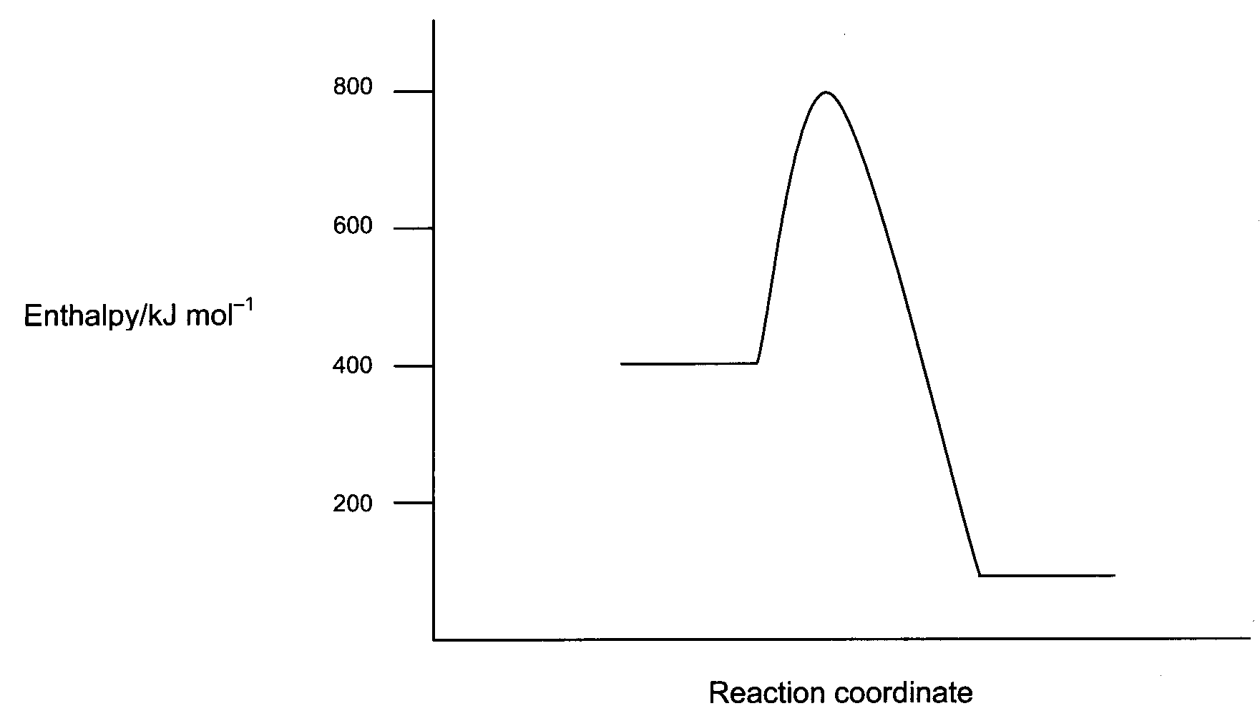
Use the potential energy diagram shown below to answer question 1.

- Which of the following gives the correct values for the enthalpy change (ΔH) and the activation energy (E_{a}) for the reverse reaction?

ΔH (kJ mol⁻¹) E_{a} (kJ mol⁻¹)
- -300 +700
- +300 +400
- -300 +400
- +300 +700

- A catalyst was added to the reaction mixture. Comparing the catalysed reaction to the uncatalysed reaction, which of the following will remain the same?

- the enthalpy change of the reaction.
- the activation energy for the forward reaction.
- the energy of the transition state
- the activation energy of the reverse reaction.

Question 3 refers to the following graph, which represents the concentrations of SO₂ and SO₃ in the reaction shown below.

SO_{2 (g)} + NO_{2 (g)} SO_{3 (g)} + NO _{(g)} ΔH = -42 kJ mol⁻¹
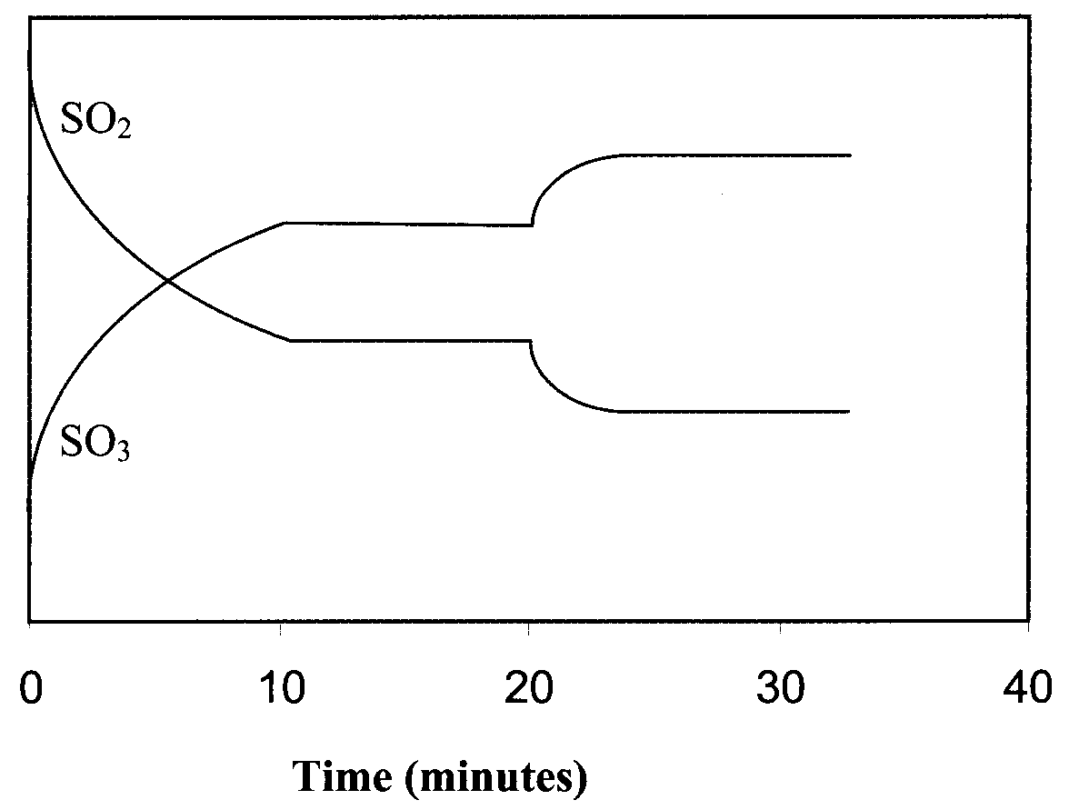

Concentration

- At the 20 minute mark, what changes could have been made to the system to produce the effects shown on the graph?

- The system temperature is increased or the concentration of NO is increased.
- The system temperature is increased or the concentration of NO₂ is increased.
- The system temperature is decreased or the concentration of NO is decreased.
- The system temperature is decreased or the concentration of NO₂ is decreased.

- If solid calcium carbonate is heated in a sealed container, the following equilibrium is established at 500°C and 600kPa pressure.

CaCO_{3 (s)} CaO _{(s)} + CO_{2 (g)} ΔH = +178.3 kJ mol⁻¹

Which of the following statements about this equilibrium is correct?

- Adding more CO₂ to the system will reduce the amount of CaO present.
- Reducing the temperature of the system will increase the amount of CaO present.
- Increasing the pressure of the system to 1000 kPa by adding inert nitrogen gas will decrease the amount of CaCO₃ present.
- Adding more CaCO₃ to the system will cause an increase in CaO and CO₂ present.

- The next question refers to the chemical process shown below.
This process has reached equilibrium in a closed system.

Cr₂O₇²⁻ _{(aq)} + H₂O _{(l)} ⇋ 2CrO₄²⁻ _{(aq)} + 2H⁺ _{(aq)}

A small amount of HCl _{(g)} is added to the system and dissolved. Which of the following lists correctly shows the changes in concentration for H₂O _{(l)}, CrO₄²⁻ _{(aq)} and Cr₂O₇²⁻ _{(aq)} as equilibrium is re-established?

[H₂O(l)] [CrO₄²⁻_{(aq)}] [Cr₂O₇²⁻_{(aq)}]
- increased decreased decreased
- decreased increased increased
- unchanged decreased increase
- unchanged increased decrease

- The following equation represents a closed equilibrium system.

2 O₃ (g) 3 O₂ (g)

The value of K for this system at 2300 °C is 2.5 x 10¹². This value tells us that;

- The reaction is extremely exothermic
- The reaction is extremely fast
- The reaction essentially goes to completion
- The reaction essentially does not occur

- The reaction of iron(III) oxide with carbon monoxide gas is shown below:
Fe₂O₃(s) + 3 CO(g) ⇋ 2 Fe(l) + 3 CO₂(g)
Which one of the following changes to the system will decrease the rate of the forward
reaction?

- decreasing the volume of the reaction vessel
- decreasing the pressure of CO(g) in the vessel
- decreasing the Fe₂O₃(s) particle size
- increasing the concentration of CO₂(g) in the system

- When pure water is kept in the fridge, the pH rises above 7. This is because;

- The water has become slightly basic
- There is a higher concentration of OH⁻ ions than H₃O⁺ ions
- The self-ionisation of water occurs to a lesser extent
- The value of K_{w} is higher

- What is the conjugate base of HC₂O₄ –?

- C₂O₄²⁻
- H₂C₂O₄
- H₃C₂O₄⁺
- H₂C₂O₄⁻

- Which of the following pairs of words best describe the acidic properties of a 0.005 mol L⁻¹ solution of H₂CO₃?

- Dilute, strong
- Dilute, weak
- Concentrated, strong
- Concentrated, weak

Use the information in the table below to answer questions 4 and 5.

Indicator | Colour (low pH – high pH) | pH range
Methyl yellow | Red – yellow | 2.4 – 4.0
Bromocresol purple | Yellow – purple | 5.2 – 6.8
Phenol red | Yellow – red | 6.8 – 8.4
Cresol red | Yellow – red | 7.2 – 8.8

- Which indicator in the table above would be most suitable to identify the end point in a titration of hydrochloric acid solution against sodium carbonate solution?

- Methyl yellow
- Bromocresol purple
- Phenol red
- Cresol red

- In an acid-base titration with an end point of pH 8.2, a chemist uses bromocresol purple as the indicator. The acid is added from the burette to the base in a conical flask and the base has an initial pH of 10.5.

What effect will this procedure have on the calculation of the unknown concentration for the base?

- The concentration calculated will be higher than its true concentration.
- The concentration calculated will be lower than its true concentration.
- The concentration calculated will be accurate.
- A calculation cannot be done as no colour change will be seen during the titration.

- Sodium oxide (Na₂O) is a strong base, while sodium carbonate (Na₂CO₃) is a weak base. If an equal number of moles of each solid was placed into separate beakers containing 100 mL water, which of the following would be correct?

- The beaker containing sodium oxide would have a lower pH
- Both beakers would contain the same concentration of sodium ions
- Both beakers would contain the same concentration of hydroxide ions
- The sodium carbonate would not have dissolved as it is insoluble

- When freshly cleaned aluminium metal is placed in dilute hydrochloric acid, a redox reaction occurs. Which of the following statements regarding the reaction is NOT correct?

- The pH of the reaction mixture would fall as the reaction proceeded
- The aluminium metal would be oxidised to form aluminium ions
- The hydrogen ions would be reduced to form hydrogen gas
- The gas formed would be positive for the ‘pop test’

- Which of the following would be classified as basic substances?

- NaOH
- NH₃
- Na₂CO₃
- CH₃COOH
- H₂CO₃

- (i), (ii) and (iii)
- (i), (iii) and (iv)
- (i) and (iii)
- (ii) and (v)

- In which of the following equations is water acting as a Bronsted-Lowry base?

- HCO₃⁻ (aq) + H₂O (l) → CO₃²⁻ (aq) + OH⁻ (aq)
- SO₄²⁻ (aq) + H₂O (l) → OH⁻ (aq) + HSO₄⁻ (aq)
- ClO⁻ (aq) + H₂O (l) → HClO (aq) + OH⁻ (aq)
- H₂PO₄⁻ (aq) + H₂O (l) → H₃O⁺ (aq) + HPO₄⁻ (aq)

- Which solution would have the highest pH?

- 1 mol L⁻¹ HNO₃
- 1 mol L⁻¹ H₂SO₄
- 1 mol L⁻¹ H₂CO₃
- 1 mol L⁻¹ HCl

- Which of the following pairs of half-cells would produce the greatest voltage under standard conditions?

- Pb / Pb²⁺ and Ag⁺ / Ag
- Zn / Zn²⁺ and Ni²⁺ / Ni
- Ni / Ni²⁺ and Pb²⁺ / Pb
- Zn / Zn²⁺ and Ag⁺ / Ag

- A beaker held a dilute solution of copper(II) sulfate. A piece of metal was added to the beaker. Slowly the blue colour of the solution faded and a salmon pink metal began to precipitate. Which of the following metals would not cause these observations?

- Magnesium
- Iron
- Nickel
- Silver

- If you had an equal mass of each of the metallic ions below, which would require the greatest number of moles of electrons to be reduced to the elemental metal?

- Mn²⁺
- Ni²⁺
- Cd²⁺
- Co²⁺

- In which of the substances below is the underlined element in an oxidation state of +3?

- HClO₂
- C₂H₂O₄
- H₂SO₃
- N₂O₃
- HPO₂

- (i), (ii) and (iv)
- (i), (iv) and (v)
- (ii), (iii) and (iv)
- (i), (ii), (iv) and (v)

- In which of the following is chlorine in the highest oxidation state?

- HClO
- Cl₂O₇
- HCl
- ClO₂

- In which of the following reactions is oxygen reduced?

- F₂O to O₂
- H₂O to H₂O₂
- SO₂ to SO₃
- H₂O₂ to O₂

- Which of the following is the strongest oxidant (oxidising agent) under standard conditions?

- Cl₂ (g)
- KMnO₄ (aq) / H⁺ (aq)
- Br₂ (l)
- Na₂Cr₂O₇ (aq) / H⁺ (aq)

- Which of the following statements regarding redox reactions are true?

- A reductant (reducing agent) will gain electrons
- The oxidation number of the reductant (reducing agent) will increase
- Oxidation numbers correspond to the number of electrons being transferred during a reaction
- Oxidation cannot happen without reduction
- Redox reactions always involve the transfer of electrons

- (i), (iii) and (v)
- (ii), (iv) and (v)
- (i), (ii) and (iv)
- (ii), (iii) and (iv)

End of Section One

Section Two: Short answer % (57 Marks)

This section has twelve (12) questions. Answer all questions. Write your answers in the space provided.

Spare pages are included at the end of this booklet. They can be used for planning your responses and/or as additional space if required to continue an answer.

  - Planning: If you use the spare pages for planning, indicate this clearly at the top of the page.

  - Continuing an answer: If you need to use the space to continue an answer, indicate in the original answer space where the answer is continued, i.e. give the page number. Fill in the number of the question(s) that you are continuing to answer at the top of the page.

Suggested working time for this section is 60 minutes.

Question 26 (1 mark)

Equation | NH₃(g) + H₂O(l) NH₄⁺(aq) + OH⁻(aq)
Equilibrium constant expression

Question 27 (4 marks)

An equilibrium is set up in a test tube by suspending some finely divided copper sulphide in a dilute solution of hydrochloric acid. The equation for the equilibrium is:

CuS(s) + H⁺(aq) Cu²⁺(aq) + HS⁻(aq)

Complete the following table, giving your answers as “increases”, “decreases” or “no change”.

Change made to the equilibrium system | Immediate effect on rate of forward reaction | Effect on equilibrium yield of HS⁻ (aq)
HC acid is passed into the solution
CuSO₄ solution is added
More finely divided CuS is added

Question 28 (7 marks)

Ammonia is an industrially important gas produced by the Haber process, as illustrated by the equation below:

N₂(g) + 3H₂(g) 2NH₃(g) ΔH = - 92 kJ mol⁻¹ (at 25°C)

The reaction is catalysed by iron (III) oxide, Fe₂O₃.

The following graph shows the partial pressures of the three species involved in the reaction:
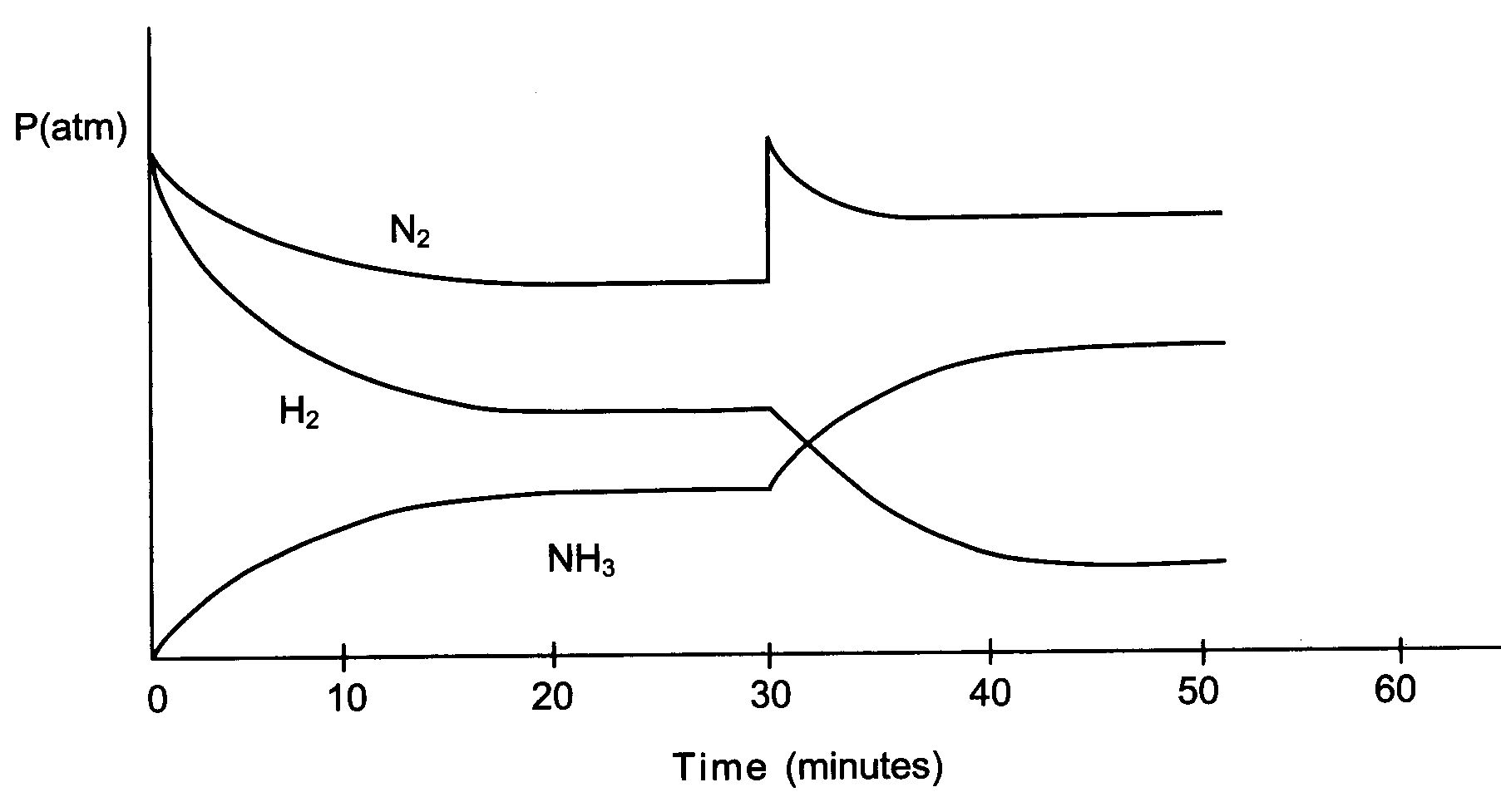
- At the start, why does the partial pressure of the H₂ gas decrease more rapidly than that of N₂ gas? (1 mark)

________________________________________________________________________________________________________________________________________________________

- What has occurred at the 30 minute mark to cause the changes shown in the graph?
(1 mark)

________________________________________________________________________________________________________________________________________________________

- By the 45 minute mark, what difference will the change imposed at the 30 minute mark have made to the rate of:

(i) the forward reaction? __________________________________________

(ii) the reverse reaction? __________________________________________ (2 marks)

At 50 minutes, the contents of the reaction vessel are rapidly compressed by reducing the volume. The changes in the partial pressures of the species are shown on the following graph, starting at 40 minutes.

P(atm)
N₂

NH₃

H₂

40 50 60 70

Time (minutes)

- Complete the graph above up to 70 minutes by showing how the partial pressures of each species change as a new equilibrium is achieved. (3 marks)

Question 29 (3 marks)

Methanol gas [CH₃OH] can be manufactured by combining hydrogen gas and carbon monoxide gas in an exothermic equilibrium reaction.
The equation for this reaction that reflects all the information given above.

2H₂(g) + CO(g) ⇋ CH₃OH(g) + heat
List one condition that would favour a fast reaction rate and one condition that would favour a high yield of methanol gas in an industrial setting. (2 marks)

Conditions for a fast reaction rate | Conditions for a high yield

- What temperature conditions would suit this reaction in an industrial setting? (1 mark)

____________________________________________________________________________

Question 30 (2 marks)

Write the equation for the reaction that occurs in each of the following procedures. If no reaction occurs, write ‘no reaction’. For full marks show only net ionic equations.

Magnesium oxide solid is mixed with hydrochloric acid solution. (1 mark)
Equation:

Barium nitrate solution is mixed with sulfuric acid solution. (1 mark)
Equation:

Question 31 (3 marks)

Water ionises according to the equation H₂O () H⁺ (aq) + OH– (aq)

At 25°C, K_{w} = 1.0 × 10^{–14} mol² L^{–2}. At 50°C, the K_{w} value changes to approximately 5.5 × 10^{–14} mol² L⁻².

Use the information above, and Le Châtelier’s principle, to predict whether the self-ionisation of water is an endothermic or exothermic process. Explain.

Question 32 (7 marks)

- 30.0 mL of a sodium carbonate solution is made up to 300 mL with distilled water. The resultant solution has a sodium carbonate concentration of 0.108 mol L⁻¹. What mass of sodium carbonate was present in the original solution. (2 marks)

- 10.0 mL of a 2.00 mol L⁻¹ H₂SO₄ solution is added to 10.0 mL of 1.50 mol L⁻¹ NaOH. What is pH of the resultant solution? (5 marks)

Question 34 (8 marks)

There are many different theories used to describe acids and bases, such as Arrhenius, Bronsted-Lowry and Lewis.

Define an acid and a base according to the Bronsted-Lowry theory. (2 marks)

Consider the following acid-base reaction.

H₂PO₄⁻ (aq) + H₂O (l) H₃O⁺ (aq) + HPO₄²⁻ (aq)

Label the conjugate acid-base pairs in the reaction above. (2 marks)

The HPO₄²⁻ ion is a weak base according to the Bronsted-Lowry theory. Write an equation showing how this ion behaves as a base in aqueous solution. (2 marks)

H₂PO₄⁻ has a K_{a} value of 6.2 x 10⁻⁸. Explain why this value makes H₂PO₄⁻ a weak acid (2 marks)

Question 35 (5 marks)

A variety of substances are listed below. Use these substances to answer the following questions. Not all substances must be used, but each substance can only be used once.

Na₂CO₃ Na H₃PO₄ NaCl
Au H₂SO₄ NaH₂PO₄ Cu
CuCl₂ Na₂SO₄ Ni

- Which two substances could be mixed together to form a buffer? (1 mark)

- Using an equation, explain what happens when OH⁻ is added to the buffer mixture.
(2 marks)

- Which substance could be classified as a ‘basic salt’? Write a hydrolysis equation to
support your answer. (2 marks)

Question 36 (7 marks)

A sample of copper (II) iodide powder was dissolved in water. This solution was then split into three (3) test tubes and a separate reaction was performed in each.

- Chlorine gas was bubbled through the first test tube. Write the oxidation and reduction half-equations for the reaction that would have taken place. (2 marks)

oxidation: __________________________________________________________

reduction: __________________________________________________________

- Zinc metal was added to the second test tube. Describe the predicted observations for this reaction. (2 marks)

Lead(II) nitrate was added to the third test tube and the molecular equation for the reaction that took place is shown below.

CuI₂ (aq) + Pb(NO₃)₂ (aq) → Cu(NO₃)₂ (aq) + PbI₂ (s)

Is this a redox reaction? Explain your answer. (2 marks)

Question 37 (2 marks)

Write a balanced half equation for the following:

NO₃⁻ NO

Question 38 (10 marks)

The following diagram shows how a car battery can be recharged while the car is being driven. Both electrodes in a car battery are lead-based and the electrolyte in the cell is sulfuric acid. The reactions occurring at each electrode are also indicated in the diagram.

power
source
H₂SO₄ (aq)
PbO₂ / PbSO₄
Pb / PbSO₄
PbSO₄ + 2 H₂O →
PbO₂ + SO₄²⁻ + 4 H⁺ + 2 e⁻
PbSO₄ + 2 e⁻ → Pb + SO₄²⁻

On the diagram above label the cathode and anode, and label and show the direction of electron flow and the direction of cation flow. (3 marks)

Write the overall equation for the recharging process. (1 mark)

- Identify the oxidant (oxidising agent) and reductant (reducing agent) in the recharging equation. Use oxidation numbers to support your answer. (3 marks)

- What is the function of the sulfuric acid electrolyte? (1 mark)

- What would happen to the pH of the electrolyte as the battery recharges? Explain your answer. (2 marks)

- Using your data sheet, calculate the overall voltage of this cell, under standard conditions (1 mark)

End of Section Two
Section Three: Extended answer % (66 Marks)

This section contains five (5) questions. You must answer all questions. Write your answers in the space provided.

Spare pages are included at the end of this booklet. They can be used for planning your responses and/or as additional space if required to continue an answer.
  - Planning: If you use the spare pages for planning, indicate this clearly at the top of the page.
  - Continuing an answer: If you need to use the space to continue an answer, indicate in the original answer space where the answer is continued, i.e. give the page number. Fill in the number of the question(s) that you are continuing to answer at the top of the page.

Suggested working time for this section is 70 minutes.

Question 39 (7 marks)

The Pilbara iron ore industry uses vast amounts of ammonium nitrate explosive to break up the rock and ore. Much of the ammonium nitrate is produced in Kwinana, Western Australia, using the following process:

Step 1: Natural gas (from the North West Shelf) is reacted with steam.
CH₄(g) + H₂O(g) ⇋ 3H₂(g) + CO(g)
Step 2: Hydrogen produced in the above process is reacted with nitrogen from the air using
the Haber Process.
3H₂(g) + N₂(g) ⇋ 2NH₃(g)
Step 3: Ammonia is reacted with oxygen in air.
4NH₃(g) + 5O₂(g) ⇋ 4NO(g) + 6H₂O(g)
Step 4: Nitrogen monoxide is reacted with oxygen in air.
2NO(g) + O₂ (g) ⇋ 2NO₂(g)
Step 5: The nitrogen dioxide produced in the reaction above is reacted with water and
oxygen to form nitric acid.
4NO₂ (g) + 2H₂O (l) + O₂ (g) ⇋ 4HNO₃(aq)
Step 6: Finally, nitric acid is reacted with ammonia to form ammonium nitrate.
HNO₃ (aq) + NH₃ (g) ⇋ NH₄NO₃(aq)

The equation for Step 3 of the process is reproduced below.

4NH₃(g) + 5O₂(g) ⇋ 4NO(g) + 6H₂O(g)

It is an exothermic reaction (ΔH = −1130 kJ) and is carried out at 900°C and atmospheric pressure in the presence of a catalyst.

Use your understanding of reaction rates and equilibrium principles to explain why these conditions are employed for this reaction.

_____________________________________________________________________________
______________________________________________________________________________________________________________________________________________________________________________________________________________________________________________________________________________________________________________________________________________________________________________________________________________________________________________________________________________
_____________________________________________________________________________
____________________________________________________________________________________________________________________________________________________________________________________________________________________________________________________________________________________________________________________

Question 40 (11 marks)

A reaction that reaches equilibrium is studied in the laboratory. In this system, two colourless gases, nitrogen trichloride and oxygen, react to produce brown nitrogen dioxide gas and light green chlorine gas. The equation for the system is

2NCl_{3(g)} + 2O_{2(g)} ⇋ 2NO_{2(g)} + 3Cl_{2(g)}

- State three observable properties that would stay constant when equilibrium is reached.
(3 marks)

What is meant by the statement “dynamic equilibrium”. (2 marks)

Write the equilibrium constant expression for the system. (1mark)

State the effect of an increase in the pressure on the yield of chlorine? Explain
(2 marks)

Complete the graph below to show what happens to the concentration of chlorine after the pressure was increased.
(2 marks)

Conc
(mol L⁻¹)

Cl₂

Time

Question 41 (16 marks)

An electrochemical cell consists of a tin electrode in a solution of 1.0 mol L⁻¹ tin(II) nitrate, to
create a Sn/Sn²⁺ half cell, and a similarly constructed half cell composed of a chromium
electrode in a solution of 1.0 mol L^{–1} chromium(III) nitrate. The two electrodes are joined by a
piece of copper wire. A salt bridge, as shown in the diagram below, joins the two solutions.

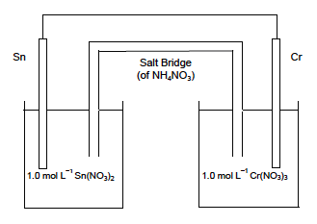

- On the diagram, label (3 marks)

(i) the anode
(ii) the direction of electron flow
(iii) the direction of cation flow in the salt bridge.

(c) Would sodium carbonate be suitable as a salt for the salt bridge? Explain. (2 marks)
_________________________________________________________________________________________________________________________________________________________________________________________________________________________________________________________________
_________________________________________________________________________________________________________________________________________________________________________________________________________________________________________________________________
_________________________________________________________________________________________________________________________________________________________________________________________________________________________________________________________________
_________________________________________________________________________________________________________________________________________________________________________________________________________________________________________________________________
1.0 mol L–1 Sn(NO3)2 1.0 mol L–1 Cr(NO3)3
Sn Salt Bridge Cr
(of NH4 NO3 )
STAGE 3 23 CHEMISTRY
See next page
(d) Why does the rate of production of electrical current from an electrochemical cell
decrease as it operates? (1 mark)
_________________________________________________________________________________________________________________________________________________________________________________________________________________________________________________________________
_________________________________________________________________________________________________________________________________________________________________________________________________________________________________________________________________
_________________________________________________________________________________________________________________________________________________________________________________________________________________________________________________________________
_________________________________________________________________________________________________________________________________________________________________________________________________________________________________________________________________
(e) During the operation of an electrochemical cell, why is it important that the anode and
cathode do not come into contact with each other? (1 mark)
_________________________________________________________________________________________________________________________________________________________________________________________________________________________________________________________________
_________________________________________________________________________________________________________________________________________________________________________________________________________________________________________________________________
______________________________________________________________________________________________________________________________________________________________________________________________________________________________________________________________

Question 42 (20 marks)

The acidity of wine is due mainly to the presence of the soluble salt potassium tartrate (KC₃H₄O₄COOH). It contains the tartrate ion which is a weak monoprotic acid. A student conducted an investigation to find the concentration of potassium tartrate in some red wine. To do this three 50 mL samples of wine were titrated with 0.0105 mol L⁻¹ NaOH. The data recorded by the student is shown here.

Volume of NaOH | First titration | Second titration | Third titration
Final reading (mL) | 9.80 mL | 10.30 mL | 10.20 mL
Initial reading (mL) | 0.05 mL | 0.2 mL | 0.1 mL
Volume used (mL)

- Write the formula for the tartrate ion present in potassium tartrate (KC₃H₄O₄COOH).
(2 marks)

- With reference to the information given write an ionisation or hydrolysis equation for the
tartrate ion? (2 marks)

- Use the information given to write a NET IONIC equation for the reaction occurring between the tartrate ion and sodium hydroxide solution? (2 marks)

- Name the apparatus used to measure the wine samples and the sodium hydroxide samples. State what is used for the final rinse of the apparatus? (4 marks)

Wine sample measured with _______________________________

Apparatus rinsed with ____________________________________

Sodium hydroxide sample measured with ______________________________

Apparatus rinsed with _____________________________________________

Use the data in the table to find the average volume of NaOH used. (2 marks)

Calculate the percentage of potassium tartrate in the wine. (4 marks)

(f) A solution of potassium tartrate (KC₃H₄O₄COOH) can act as a buffer. What does this mean? Explain how this could occur. (4 marks)

Question 43 (6 marks)

The dry cell and the lead acid cell are two commercial galvanic cells. The following
questions refer to the use and operation of these two cells.

- Some of the components of the dry cell and lead acid cell are listed here. State to which cell they belong and in a few words state their role in the operation of the cell.

Zinc Cell __________________ role _______________________________________________ (1)
PbO₂ Cell __________________ role _______________________________________________ (1)
Porous paper Cell __________________ role
_____________________________________________________________________________________________________________________________________________________ (1)
Graphite Cell __________________ role ___________________________________________ (1)

- Write the oxidation half reaction for each cell.
dry cell _________________________________________________________________________ (1)
lead acid cell _____________________________________________________________________ (1)

Question 44 (6 marks)

Write separate half equations and an overall redox equation for the following reactions.
- H₂S _{(aq)} + Cl₂ _{(g)}  S _{(s)} + Cl⁻ _{(aq)}

- MnO₄⁻ _{(aq)} + C₂O₄²⁻ _{(aq)}  Mn²⁺_{(aq)} + CO₂ _{(g)}

- Zn _{(s)} + VO₃⁻ _{(aq)}  Zn²⁺ _{(aq)} + VO²⁺ _{(aq)}

END OF QUESTIONS

